

**SUMMER TRAINING REPORT**

On

***Android App Development***

Submitted by

**Mohd Owais Naim**

**CSJMA15001390163**

**University Institute of Engineering And Technology,CSJMU, Kanpur**

(June-July, 2018)

**DECLARATION**

I hereby declare that I have completed my six weeks summer training at Udemy from May 20, 2018 (start date) to July 3, 2018 (end date) under the guidance of Muhammad Ali Yasin . I have declare that I have worked with full dedication during these weeks of training and my learning outcomes fulfill the requirements of training for the award of degree of Btech In Information Technology , University Institute of Engineering and Technology, CSJMU, Kanpur

(Signature of student)

Name of Student: Mohd Owais Naim

Registration no:

# ACKNOWLEDGEMENT

I wish to express my gratitude to my tutor Muhammad Ali Yasin at Udemy for providing me an opportunity to do my internship and project work in “Android App Development”. Under his guidance I have completed my project and tried my best to implement what I had learnt till now.

I sincerely thank sir, for their guidance and encouragement to do my internship.He also help me by updating us about the information of what to do and not to do during our internship and help us with all. I also thanks my friend for helping me with my problem that I face in my project.

|  |  |  |
| --- | --- | --- |
|  | **TABLEOFCONTENT** |  |
| PAGENO. | | |
| CHAPTER 1. | Introduction | 1 - 2 |
| 1.1 | App .................................................................................................... | 1 |
| 1.2 | Android .............................................................................................. | 1 |
| 1.3 | History ............................................................................................... | 1 |
| 1.4 | Android Version ................................................................................. | 2 |

|  |  |  |  |
| --- | --- | --- | --- |
| CHAPTER | 2. | Knowing Android .......................................................... | 3 - 5 |
|  | 2.1 | Android App Development .................................................................. | 3 |
|  | 2.2 | Java in Android App Development ...................................................... | 3 |
|  | 2.3 | Android SDK ........................................................................................ | 4 |
|  | 2.4 | API Level .............................................................................................. | 4 |
|  | 2.5 | Features of Android .............................................................................. | 4 |
|  | 2.6 | Android Application .............................................................................. | 5 |
| CHAPTER | 3. | OVERVIEW AND STARTING WITH ANDROID ....... | 6 - 13 |
|  | 3.1 | Overview .............................................................................................. | 6. |
|  | 3.2 | Android Virtual Device ........................................................................... | 7 |
|  | 3.3 | Application Component .......................................................................... | 7 |
|  | 3.4 | Additional Component ............................................................................ | 8 |
|  | 3.5 | Creating our first android app ................................................................ | 9 |
| CHAPTER | 4. | SOME IMPORTANT CONCEPT IN ANDROID ............. | 14 -17 |
|  | 4.1 | .java File ................................................................................................... | 14 |
|  | 4.2 | .xml File ................................................................................................... | 14 |
|  | 4.3 | Manifest File ............................................................................................ | 15 |
|  | 4.4 | ANDROID UI WIDGETS ....................................................................... | 15 |

PAGENO.

4.5 Some of UI Widgets .............................................................................. 15

4.6 Camera ................................................................................................ 16

4.7 Permission ........................................................................................... 17

‘

4.8 Example…………………………………………………………………………

* + 1. – Seek Bar
    2. – Coffee Shop

Conclusion ................................................................................................... 31

Bibliography .................................................................................................

**Chapter – 1 Introduction**

* 1. What is an app?

App is an abbreviated form of the word "application". An application is a software program that is designed to a specific function directly for the user which can be access easily.

* 1. What is an Android?

Android is an open source operating System for mobile devices such as smart-phones and tablet,computers. Android offers a unified approach to which means developers need to develop only for Android, and their applications should be able to run on different devices powered by android.

Android was developed by the Open Handset Alliance(OHA) , led by Google, and other companies. Android is mainly based on direct manipulation ,using touch gestures that looses correspond to real world actions. It provide us with the manipulate

on-screen object,along with a virtual keyboard for text input.

### History of Android :

Android was initially developed by Android Inc., the code names of android ranges from A to P(cont..).

Founded by Andy Rubin in Palo Alto,California, United States in Oct 2003. Android word is actually reffered to as robot

Android was named after the nickname of Andy Rubin by their co-workers for his love for robot.

Google acquired android Incorporation on 17th Aug,2005.

Android was developed by the Open Handset Alliance(OHA) for camera phone, led by Google, and other companies.

But shifted to smart-phones due to low market of cameras at that time. HTC launches the first android mobile.

### Android Version:

* + 1. Android 1.0, 1.1(Base,Base_1_1)
    2. Android 1.5(Cupcake)
    3. Android 1.6(Donut)
    4. Android 2.0(Eclair)
    5. Android 2.0.1(Eclair_0_1)
    6. Android 2.1.x(Eclair_MR1)
    7. Android 2.2.x(Froyo)
    8. Android 2.3 - 2.3.2(Gingerbread)
    9. Android 2.3.3 - 2.3.4(Gingerbread_MR1)
    10. Android 3.0.x, 3.1.x, 3.2(HoneyComb, HC _MR1, HC_Mr2)

11. Android 4.0 - 4.0.2, 4.0.3 - 4.0.4((Ice_Cream_Sandwich,ICS_MR1) 12. Android 4.1 - 4.1.1, 4.2 - 4.2.2,4.3(Jelly_Bean, JB_MR1, JB_MR2)

1. Android 4.4, 4.4W (Kitkat, K_Watch)
2. Android 5.0, 5.1(Lollipop, L_MR1)
3. Android 6.0 (Marshmallow)
4. Android 7.0 (Nougat)
5. Android 8.0,8.1 (Oreo)
6. Android 9.0 (Pie)

# CHAPTER : 2 KNOWINNG ANDROID

We will start our Android application development on any of the following operating systems:

Microsoft Window XP or later version.

Mac OS X 10.5.8 or later version with Intel chip Linux including GNU Library with Intel chip.

### Android App Development.

Android app is a combination of different source code in a single place whose action can be performed just by a single touch.

Example:- Suppose if we want to add two no’s then we just have to click on the calculator app and enter two no’s and the operand that we have to perform. It makes our work much easier and this are much user friendly.

So what happen ? How it calculated the answer.

Android programming is based on java programming language so if we have basic understanding on Java programming then it will be a fun to study Android app development.

### Java in Android App Development.

Java is a programming language that doesn’t compile to native processor code but rather it refers to virtual machine which understands an intermediate format i.e; java byte-code. Each platform that uses java to run needs a virtual device.

An android app uses a android application that runs on android platform. It build on custom virtual machine that gives its user the addition usage and application power and

a user friendly environment. Android actual virtual machine is called Dalvik.

### Android Software Development Kit(Android SDK) :

Apps that extend the functionality of device is written using Android SDK and often using java programming language.The SDK includes a set of development tools, including a debugger, software libraries,a handset emulator, sample code,etc.

Initially Google supported Integrated Development Environment(IDE) i.e; Eclipse using the Android Development Tools(ADT) plugins. Other development tools are also available such as Native Development Kit(NDK). Android Studio that is based on Intellij IDEA developed by Google as its primary IDE for android app development. Android is a selection of third-party application which can be acquired by users by downloading and installing the Android Application Package(APK) file.

### What is API Level ?

API Level is an integer value that uniquely identifies the framework API revision offered by a version of the Android platform.

### Features of Android :

It is an open source user friendly software It has beautiful user interface

It reduced cost of development

It has rich development environment Inter application Integration

It support single and bi-directional text

It uses Dalvik virtual machine- optimized version for mobil

### Android Application :

They are generally developed in the java language using the Android SDK Android applications can be packaged easily and sold out either through a store such as Google play,etc.

There are many android applications that we already know and uses them few are music,news,weather,etc

Many android application are also available for free most of them are already available in play store.

This apps are compatible with almost every platform but few are also available for the specific platform..

# CHAPTER 3:

**OVERVIEW AND STARTING WITH**

**ANDROID**

## Overview

Android applications are freely available and can be downloaded from the Web. Following is the list of software's you will need before you start your Android application programming.

This all software required in the installation of Android application.This setup is required for the configuration with RAM less or more than 4gb:

Java JDK5 or JDK6

Download the latest version of Java JDK and install the JDK and set the environmental path for it.

Android SDK

Download Android SDK from Android’s official website : <http://developer.android.com/sdk/index.html>

If you install SDK either on Mac OS or Linux, follow the instruction and setup the environment path.

Launch Android SDK Manager using option All Program>Android SDK Tools>SDK Manager

Eclipse IDE for Java Developers

Check for the version that is compatible with your device and install it.

Or, Android Development Tools (ADT) Eclipse Plugin

This step will help you in setting Android Development Tool plugin for Eclipse.

Let's start with launching Eclipse and then, choose Help > Software Updates > Install New Software

## Android Virtual Device

To test our android application we will need a virtual Android device. Before start writing our code we create an Android Virtual Device Android operating system is a stack of software components which is roughly divided into five sections and four main layers :

Application

You will find all the Android application at the top layer. You will write your application to be installed on this layer only

Application Framework

The Application Framework layer provides many higher-level services to applications in the form of Java classes.

Libraries

There is a set of libraries including open-source Web browser engine WebKit, well known library libc, SQLite database,etc.

And , Android Runtime :

This is the third section of the architecture and available on the second layer from the bottom. This section provides a key component called Dalvik Virtual Machine which is a kind of Java Virtual Machine specially designed and optimized for Android

Linux Kernel

At the bottom of the layers is Linux,This provides basic system functionality like process management, memory management, device management like camera, keypad, display etc.

## Application Component

Application components are the essential building blocks of an Android application. These component are loosely coupled by the application manifest file, i.e;

Android-

-Manifest.xml

Following four main component that can be used within an Android application :

1. Activities :- They dictate the UI and handle the user interaction to the smartphone screen public class MainActivity extends Activity

{ }

1. Services :- They handle background processing associated with an application public class MyService extends Service

{ }

1. Broadcast Receivers :- They handle communication between Android OS and applications public class MyReceiver extends BroadcastReceiver

{ }

1. Content Providers :- They handle data and database management issues. public class MyContentProvider extends ContentProvider

{ }

## Additional Component :

There are additional components which will be used in the construction of above mentioned entities, their logic, and wiring between them.They are :

1. Fragments :- Represent a behavior or a portion of user interface in an Activity.
2. Views :- UI elements that are drawn onscreen including buttons, lists forms etc
3. Layouts :- View hierarchies that control screen format and appearance of the views
4. Intents :- Messages wiring components together.
5. Resources :- External elements, such as strings, constants and drawable pictures
6. Manifest :- Configuration file for the application
   1. ***Creating our first android app : Displaying “Hello World”* :**

The first step is to create a simple Android Application using Android Studio.Follow the option **File -> New -> New Project ->Enter application name in the pop-up window.Then select a Empty activity->next->Activity name->Finish.**

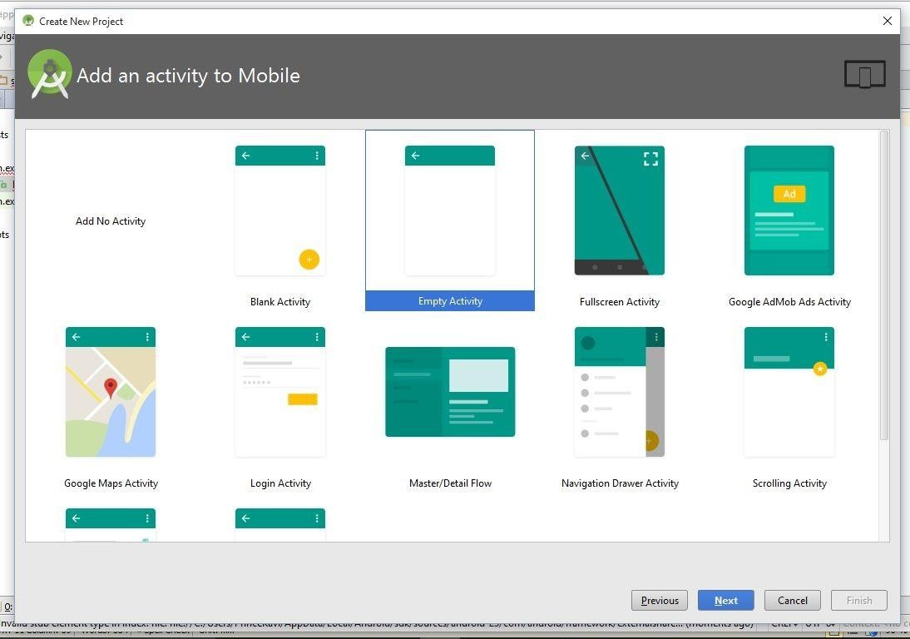

* + 1. **Empty Activity selected**

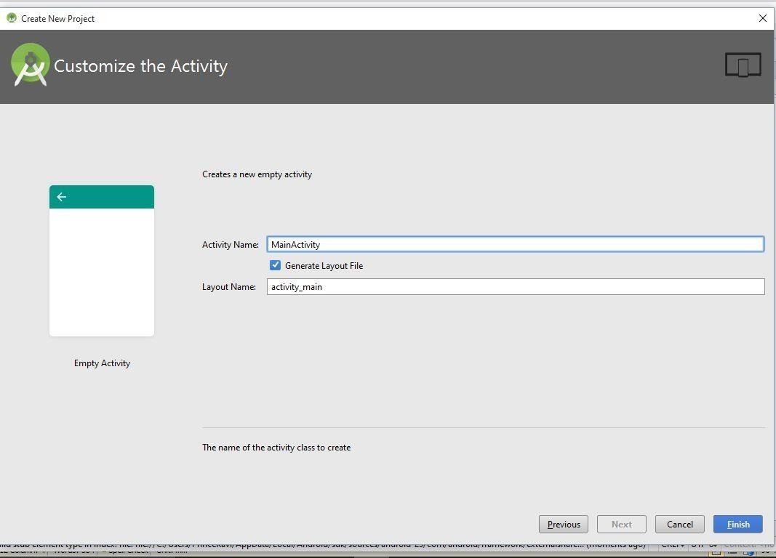

* + 1. **Activity name, it automatically create a layout name file related to your activity**

**Fig. 3.1 Creating Activity**

**Java coding for hello world : MainActivity.java**

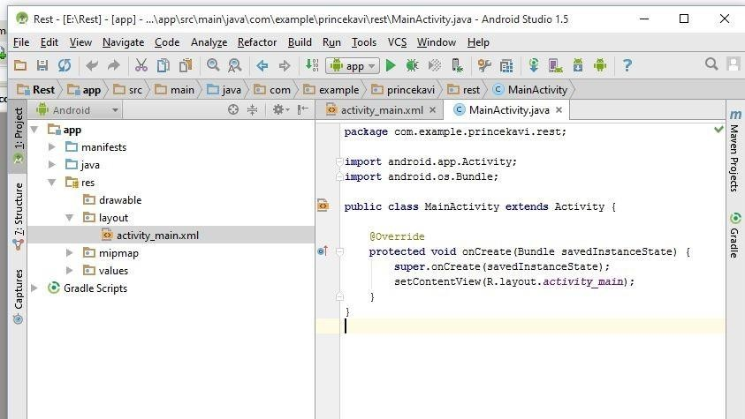

* + - 1. **MainActivity.java file**

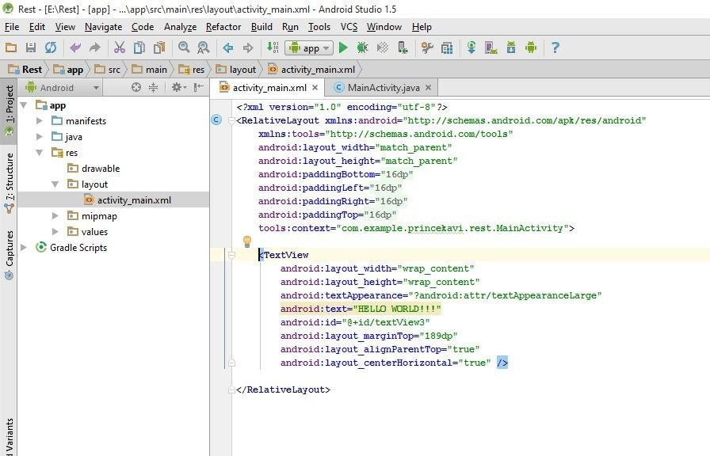

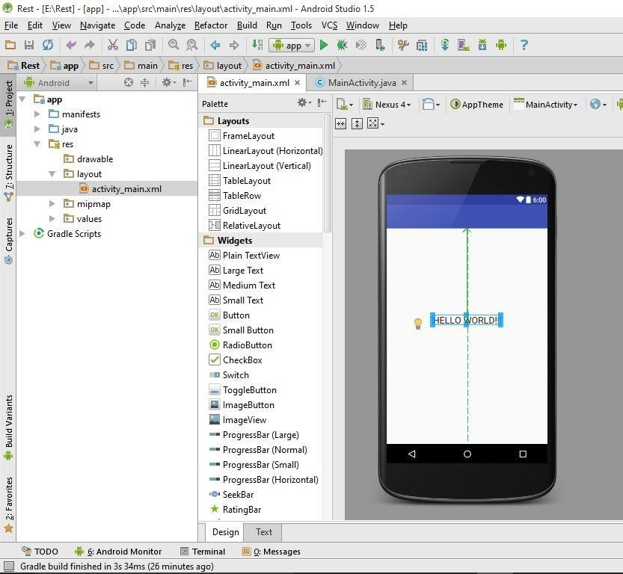

* + - 1. **Coding and design view of xml file**

**Fig. 3.2** File extension for MainActivity is activity_main.xml

**Result on the Android Virtual Device is :**

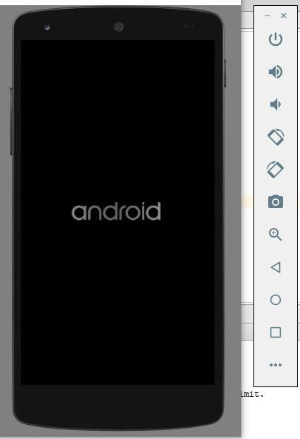

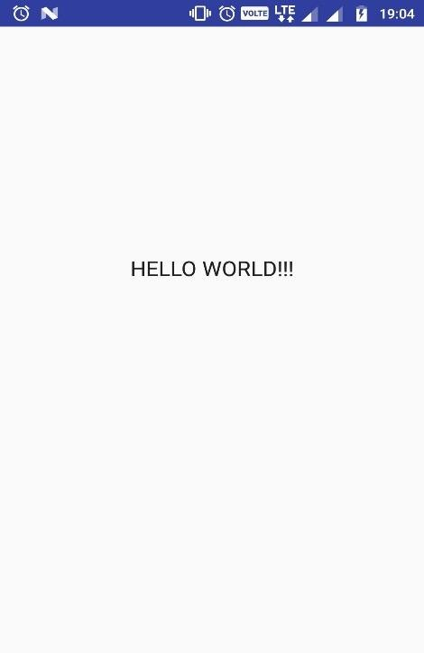

**Fig. 3.3 Android Virtual Device Showing result**

# CHAPTER 4:

**SOME IMPORTANT CONCEPT IN ANDROID**

Before going to project that I made we need to know some basic concept of Android for better understanding.

Since every project that we do in android studio must contain this files:-

.java file

.xml file AndroidMenifest file

#### .javaFile :

This file include all the codes and logic written in it.

We can open it in the android project -> app -> java -> com.example.*username*.*filename* -> MainActivity.java

When we run our program methods that are called :

- onCreate(Bundle) :- It is used to initialize our activity.

-setContentView(int) :- It is a layout resource defining our User

Interface.

-findViewById(int) :- It is used to retrieve widgets in the that UI that

we need to interact.

-onPause() :- Where we deal with the user leaving activity.

#### .xmlFile :

It is used to define the actual User Interface of our application.

We can open the .xml from app -> res ->layout -> ActivityName.xml

We can find all the elements or the tools that we want to use in our project.

It has two different layout i.e; a coding layout where we can code for our required elements needed like buttons, text views,etc.

Or, we can directly drag and drop the required elements in the given design layout.

The Android framework gives us the flexibility to use either or both of these methods for declaring and managing our apps UI.

#### Manifest File :

Every application must have an AndroidManifest.xml file in its root directory. It provides an essential information about app to the android system.

It provides us the information about the permission that we hav given the app to access our device.

No. of activities we have use in our app

#### ANDROID UI WIDGETS :

A widget is a simple application extension that is often part of a larger application that are already inbuilt.

It comes in all shapes and sizes, and are customizable and are available for quick access.

* 1. **Some of UI Widget are:**

Button : Android Button represents a push-button. The

android.widget. Button is subclass of TextView class and Compound-Button is the subclass of Button class. Types of button are : RadioButton , ToggleButton, ImageButton, etc.

Spinner : Android Spinner is like the drop-down box of AWT or Swing.

It can be used to display the multiple options to the user in which only one item can be selected.

Android Spinner class is the subclass of AsbSpinner class.

ToggleButton : Android ToggleButton and Switch both are the subclasses of CompoundButton class.

Android Toggle Button can be used to display checked/unchecked state on the button.

It is beneficial if user have to change the setting between two states. Exp : Bluetooth on/off, music sound on/off, etc.

CheckBox : Android CheckBox class is also the subclass of CompoundButton class.

Android CheckBox can be either checked or unchecked. We can use more no. of CheckBox.

Many Android application uses our device component such as camera, Bluetooth,etc. For that all we have to give special permission in the manifest file.

## Camera :

We can directly integrate the camera into your application via the Camera API. Using the camera on the Android device can be done via integration of the existing Camera application. In this case you would start the existing Camera application via an Intent and to get the data after the user returns to our application.

* 1. **Permission given:**

In the manifest file we give the following permission to the application to access the hardware component i.e; camera :

<uses-feature android:name="android.hardware.Camera"/

>

<uses-permission android:name="android.permission.CAMERA" />

After giving permission to the app we also have to give the special permission to the app through our device to the location ,

Setting -> apps -> open app -> permission -> camera allow -> close setting

* 1. 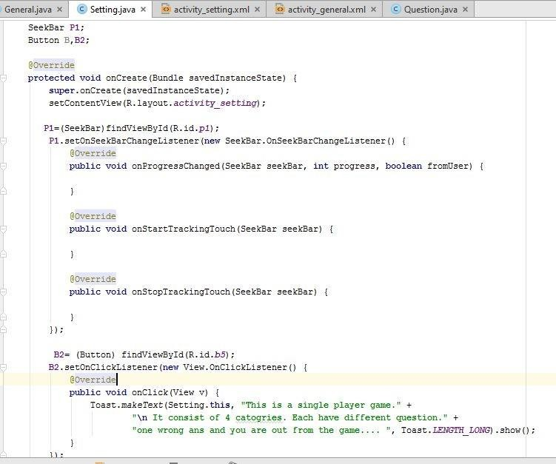EXAMPLE 4.8.1- SEEK BAR

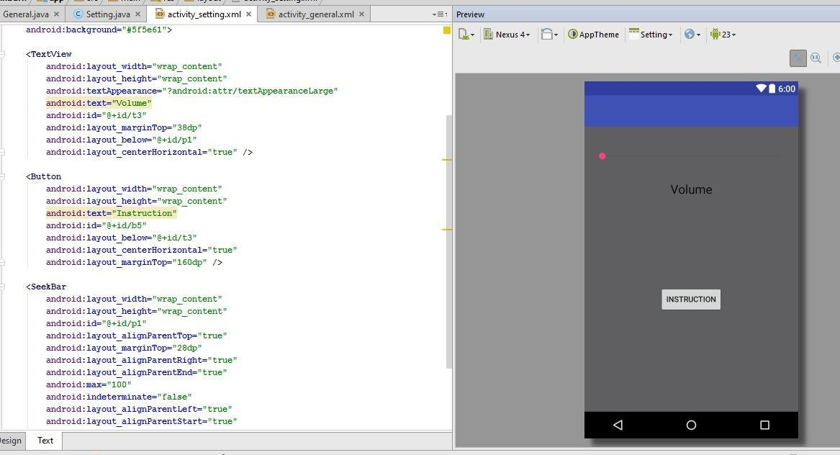

It consist of seekbar that control volume and a button that give instruction about the project.

4.8.2 Coffee Shop (Main Project)

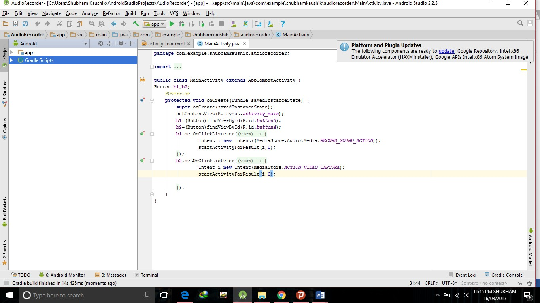

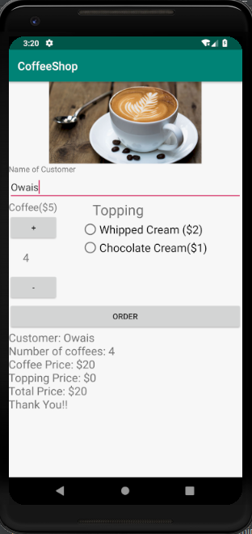

**4.9 Methods and function :**

As many of the topic has been mention in my project frequently. So to know more about the topic it has been declared within below :

**onClickListener** :- onClickListener is used to assign a button what to do on clicking using button.setOnClickListener(new onClickListener) in the activities onCreate - method.

**Intents** :- Intents are objects of the android.content.Intent type.It can be started using startActivity( ) method. It is used to move one activity to another .It contain the data via a Bundle.

**Seekbar** :- A seekbar is an extension of a progressbar that adds a draggable thumb.The user can drag the thumb left or right to set the current progress level or use the arrow key.

Clients of the SeekBar can attach a SeekBar.OnSeekBarChangeListener to be notified of the user’s actions.

**Toast** :- A Toast can be used to display information for the short period of time. A Toast contains message to be displayed quickly and disappear after sometime.The android.widget.Toast class is the subclass of java.lang.Object class.

**Syntax** :- Toast.makeText(Context context,CharSequence text,int duration).show( );

**CONCLUSION**

After completing this project, I concluded that this project was the good opportunity to implement my information that I have learnt during my internship program. This project is more informative and more helpful for understanding the concept of the android app development. This project is only a small and easy one but it is enough to implement my concept. I can further try much harder to make much more efficient and useful app that can benefit to other.

**Bibliography**

Following are the links from which all the information have been taken :

1. https://developer.android.com/training/basics/index.html
2. https://developer.android.com/training/basics/concept/creating- project.html
3. <http://www.hiddenbrains.com/android-application-development.html>
4. [http://www.letsnurture.com/services/mobile/android-mobile- application-devel](http://www.letsnurture.com/services/mobile/android-mobile-application-development.html) opment.html
5. https[://www.tutorialspoint.com/android/](http://www.tutorialspoint.com/android/)